Hello! This is the english version of the technical exam for the job vacancy of
"IT Support Technitian" for the business called "eShard". I will attach the corresponding PDF with the answers within it, however I am instructed to create this README file (which will be available in french as well) so lets dive into it!

Tasks:
➔ Setup a Docker-based Web Service:
I will run this docker container within debian 12 as a host, running on a partition in my 1tb SSD.

◆ Pull and run a simple web app using Docker (e.g., nginx or a basic Python
app).

We will download and setup up an nginx server that runs within a docker container[2]:

◆ Expose it on port 8080.
◆ Use Docker volumes to persist configuration or logs.
➔ Secure the Container & Host
◆ Limit container privileges (no root, no unnecessary capabilities).

So we are gonna first pull the NGINX image from docker’s official repo, give it the name “nginx-server” and expose it to port 80:80:

docker run -d –name nginx-server -p 80:80 nginx:latest
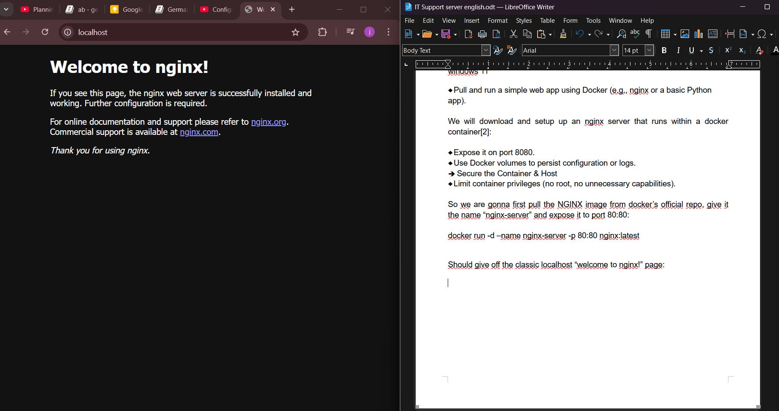
Should give off the classic localhost “welcome to nginx!” page:

The container, stored logically within windows, appears in docker desktop as:
C\Users\royer\AppData\Local\Docker\wsl
However, if I want to actually access the files and everything, I will need to write this either in the windows explorer URL or within the CMD [3]:
\\wsl.localhost\docker-desktop\mnt\docker-desktop-disk\data\docker\volumes\nginx-volume
Now, to secure our container, lets take the following steps[5][6]:
- Change root user: by default, docker will always run your app as a “root”, but this is highly discouraged. In the real world, the armies of bots who will try to bring down your server will first and foremost target the user “root” with common used passwords that are found within hacker’s “stolen passwords” databases.
Now, lets move on from “rootless” users to “unnecessary privileges”[9]:
We do actually have a very stripped down image of nginx for docker, which disallows root and ships without even a way to ping without going into the bash of each container and installing it yourself. We can set it up with a compose.yaml file, but it needs some thinkering before it can be useful.
I’m going to create a sample wordpress site, with its own database and everything, running on nginx as its reverse proxy, however debian insists on using apache no matter what. Also, if nginx needs to access directories or any kind of file within debian, debian will not allow it to because it needs root privileges. That, and the usual linux directory permission issues, which can all be solved through the terminal, but they can also be scripted so this project comes out of the box, ready to be deployed anywhere no matter what.
We are going, then, to first create in our nginx folder, the following bash script: nginx-entrypoint.sh, and add the following code:
#!/bin/sh

chown -R www-data:www-data /var/log/nginx

if [ -f /var/www/html/index.html ]; then
mv /var/www/html/index.html /var/www/html/index.html_bkp
fi

exec /docker-entrypoint.sh nginx -g "daemon off;"

Then we are going to run this in terminal to allow docker to reach this file without permit issues from debian:
chmod +x ./nginx/nginx-entrypoint.sh
The whole compose.yaml thing will end up looking like this:
services:
reverseproxy:
image: nginxinc/nginx-unprivileged:latest
container_name: nginx-container
volumes:
- ./nginx/core.conf:/etc/nginx/conf.d/core.conf
- ./nginx/proxy.conf:/etc/nginx/conf.d/proxy.conf
- ./nginx/wordpress1.conf:/etc/nginx/conf.d/wordpress1.conf
- ./nginx/wordpress2.conf:/etc/nginx/conf.d/wordpress2.conf
- ./nginx/html:/var/www/html
# logging mounted volumes
- ./nginx:/etc/nginx/conf.d
- ./app/static:/static
- ./log/nginx:/var/log/nginx
# mounting the script, remember: - file where its stored : path inside docker
- ./nginx/nginx-entrypoint.sh:/etc/nginx/conf.d/nginx-entrypoint.sh
# running the entrypoint script
entrypoint: ["/etc/nginx/conf.d/nginx-entrypoint.sh"]

ports:
- "8080:80"
- "443:80"
links:
- web1
- web2
- db1
- db2
restart: on-failure:3

web1:
image: wordpress:php8.2-fpm
container_name: wordpresss1
volumes:
- ./wordpress/wp1:/var/www/html
links:
- db1
environment:
- WORDPRESS_DB_HOST=db1
- WORDPRESS_DB_USER=wp1
- WORDPRESS_DB_PASSWORD=wordpress1234
- WORDPRESS_DB_NAME=wordpress1
# memory usage script
command: /var/spool/cron/crontabs/chemiloco

web2:
image: wordpress:php8.2-fpm
container_name: wordpresss2
volumes:
- ./wordpress/wp2:/var/www/html
links:
- db2
environment:
- WORDPRESS_DB_HOST=db1
- WORDPRESS_DB_USER=wp1
- WORDPRESS_DB_PASSWORD=wordpress1234
- WORDPRESS_DB_NAME=wordpress1
# memory usage script
command: /var/spool/cron/crontabs/chemiloco
db1:
image: mysql:latest
container_name: db1
volumes:
- ./mysql/db1:/var/lib/mysql
- ./mysql/conf1.d:/etc/mysql/conf.d
environment:
MYSQL_ROOT_PASSWORD: "Admin1234"
MYSQL_DATABASE: "wordpress1"
MYSQL_USER: "wp1"
MYSQL_PASSWORD: "wordpress1234"

db2:
image: mysql:latest
container_name: db2
volumes:
- ./mysql/db2:/var/lib/mysql
- ./mysql/conf2.d:/etc/mysql/conf.d
environment:
MYSQL_ROOT_PASSWORD: "Admin1234"
MYSQL_DATABASE: "wordpress2"
MYSQL_USER: "wp2"
MYSQL_PASSWORD: "wordpress1234"

You also need to edit your hosts file, at least in any sort of linux distro, that can be found within /etc/. I have included how mine runs here, as if you don’t edit this so localhost reacts to your domains, your website will never work.

- Configure a firewall to allow only SSH (port 22) and HTTP (port 8080). Ensure that DNS is working but no other outbound traffic is allowed.
There are a few cavebeats to using firewalls in docker. Right out of the box, if you use the default iptables port filtering within most linux distros, it can break docker and disallow it from reaching the net. If multiple containers use the same port and only one is allowed per port, then we need to specify container IP and service name. Some other services like ufw enter in conflict with docker’s networking mapping [21]. So here, we are going to use firewalld [20] :

apt update && apt install firewalld -y
systemctl enable --now firewalld
# Confirm that the service is running
firewall-cmd –state

We will create our daemon.json file , as rootless mode ofc, within ~/.config/docker/daemon.json . And add the following simple rule:

{
“iptables”: false
}

Now, lets configure firewalld within the terminal, to allow docker containers to access the internet, and allow dockers to access the host (debian) ports, within an interface called “trusted zone”:

sudo systemctl enable --now firewalld
sudo firewall-cmd --zone=public --add-masquerade --permanent
sudo firewall-cmd --reload

Now lets show the docker interfaces to find out its name:
ip link show
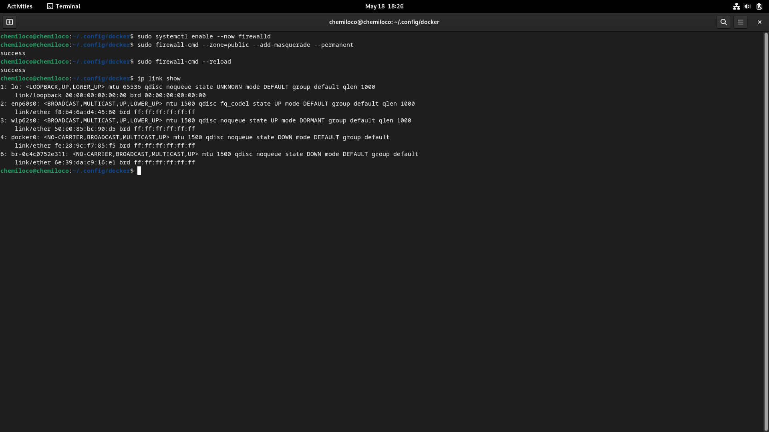
Here we can see our docker is called “docker0” , so our firewalld config should look:
firewall-cmd --permanent --zone=trusted –add-interface=docker0
fireall-cmd --reload

We need to see which IP address or interface our docker uses to reach the internet

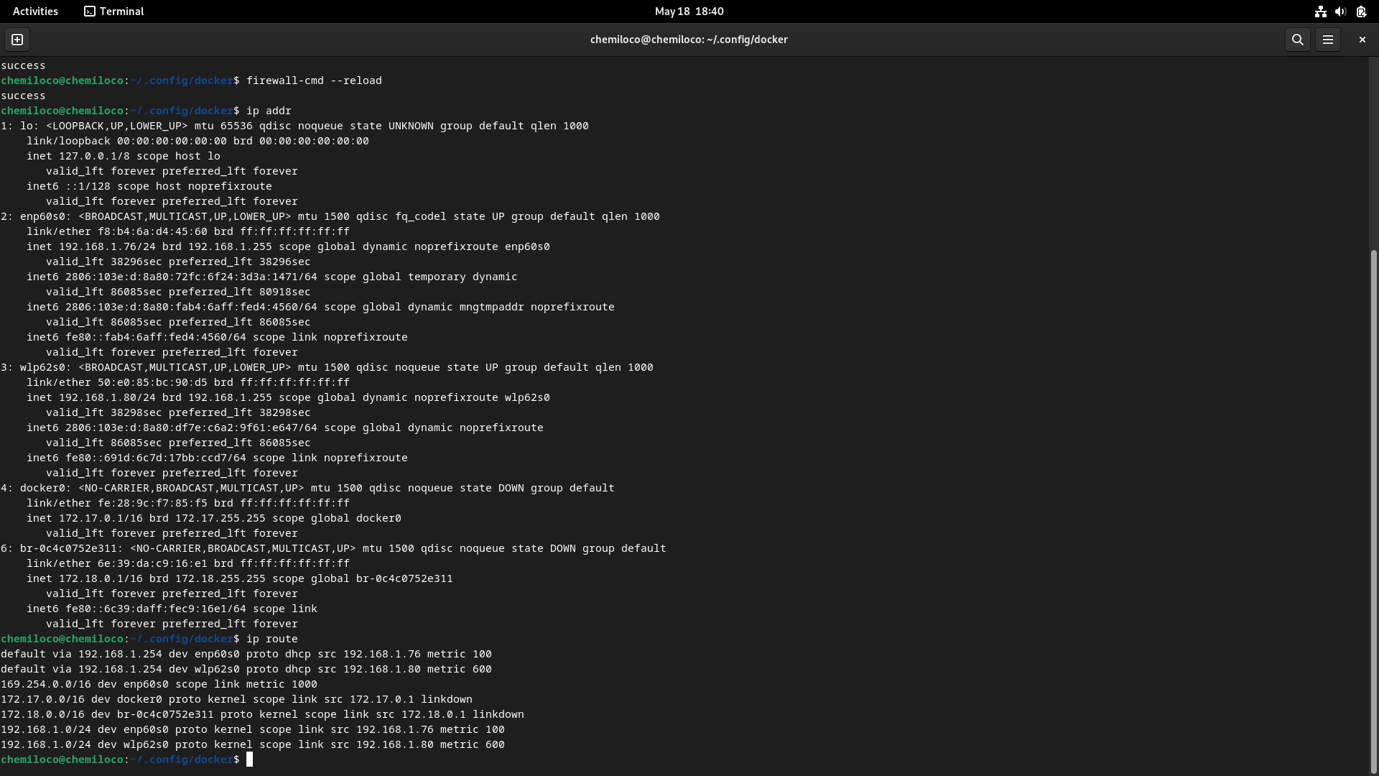
Docker uses the host, debian, as a bridge, to reach the internet [24]. So, with that in mind, we know from the previous screenshot that the interface being used is “enp60s0”. Hence, the following firewalld config would look like:
firewall-cmd --permanent --zone=public --add-interface= enp60s0
firewall-cmd --reload

Now to open the ports SSH (22) and HTTP (8080) we simply do the following:
firewall-cmd --permanent --zone=public --add-port=8080/tcp
firewall-cmd --permanent --zone=public --add-port=22/tcp
firewall-cmd --reload

Lets ensure all changes are saved [23]:
firewall-cmd –runtime-to-permanent

We can log in to the bash of, wordpresss1 for example, and do a simple ping to google (lets remember that the image being used here of nginx is very restrictive and we have to download ping utilities):
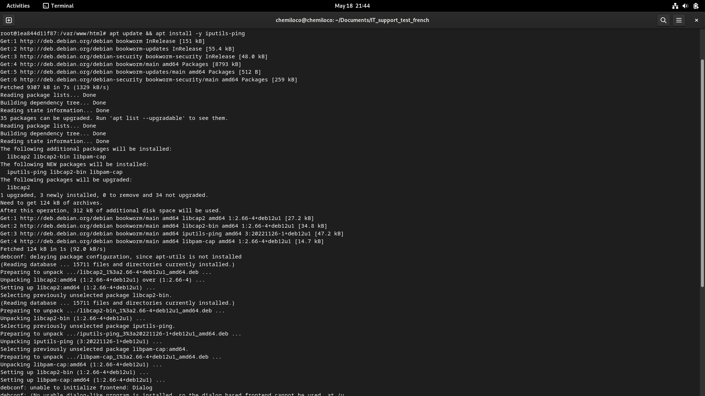
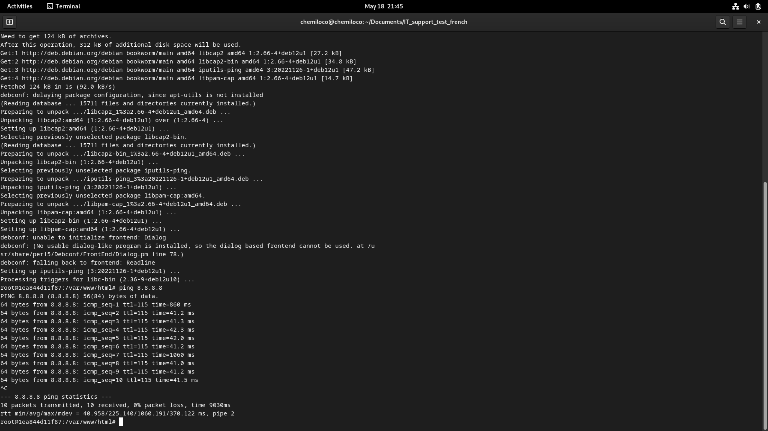
Now, lets ensure DNS works but no other outbound traffic is allowed [26]:
sudo firewall-cmd --permanent --zone=docker –set-target=DROP
sudo firewall-cmd --permanent --zone=docker --add-port=53/udp
sudo firewall-cmd --permanent --zone=docker –add-port=53/tcp
sudo firewall-cmd –reload
As we can see in the following image, we cannot even download packages from linux repos:

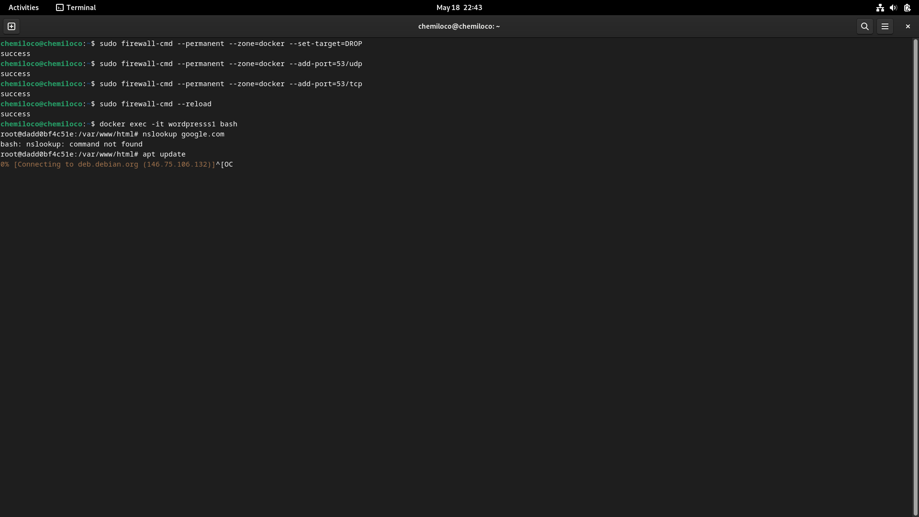
Now lets add basic monitoring:
◆ Configure basic logging to track access to your web service.

We will use the tools of both nginx and docker to keep track of all access to our web service. Lets start with nginx[31][33]:
nginx already carries this service on its own image, so its as simple as mounting the corresponding volumes like this:
volumes:
- ./nginx:/etc/nginx/conf.d
- ./app/static:/static
- ./log/nginx:/var/log/nginx
depends_on:
- reverseproxy
We also have to modify the core.conf file in our project, by adding the following:
http {
access_log /var/log/nginx/access.log;
error_log /var/log/nginx/error.log;
}

Now, for our logs, we need to create yet another daemon.json file within the directory /etc/docker/daemon.json (for linux distros), and write the following inside[32]:
{
"builder": {
"gc": {
"defaultKeepStorage": "1GB",
"enabled": true
}
},
"debug": true,
"experimental": false,
"insecure-registries": [],
"registry-mirrors": [],
"log-driver": "json-file",
"log-opts": {
"max-size": "20m",
"max-file": "5",
"compress": "true",
"env": "os"
}
}

We then add a simple “command: sudo chown -R www-data:www-data /var/log/nginx” to our compose.yaml file, under the reverseproxy service tag, so we don’t run into issues about permissions at build[35].
We can enter a container, in this case wordpresss1.com, and see that the logs are being registered:

- Create a cron job that alerts (e.g., writes to a file) if memory usage exceeds 70%.

We are going to base off this script [37] that prints to the console whenever a container’s allocated memory exceeds 70% of its capability. We are going to call it “system_monitor.py” and it will get stored within the base project directory, “docs/other_files” for both wordpresss1 and wordpresss2. We just change the cpu_usage = psutil.cpu_percent(interval=1) interval parameter to 70 [38].

We are going, after creating the file in the corresponding folder, run “crontab -e” in terminal and run the following thing:

*/15 * * * * /usr/bin/python3 ~/Documents/IT_support_test_french/docs/other_files/system_monitor.py

And gonna save it in “/tmp/crontab.EcJfLH/crontab” , allegedly, when the real path within debian is actually “/var/spool/cron/crontabs/ [39].

We are going to use the path file “/var/spool/cron/crontabs/chemiloco”, where “chemiloco” is the name of the crontab. We are going to do this for both domains, webpresss1 and webpresss2.

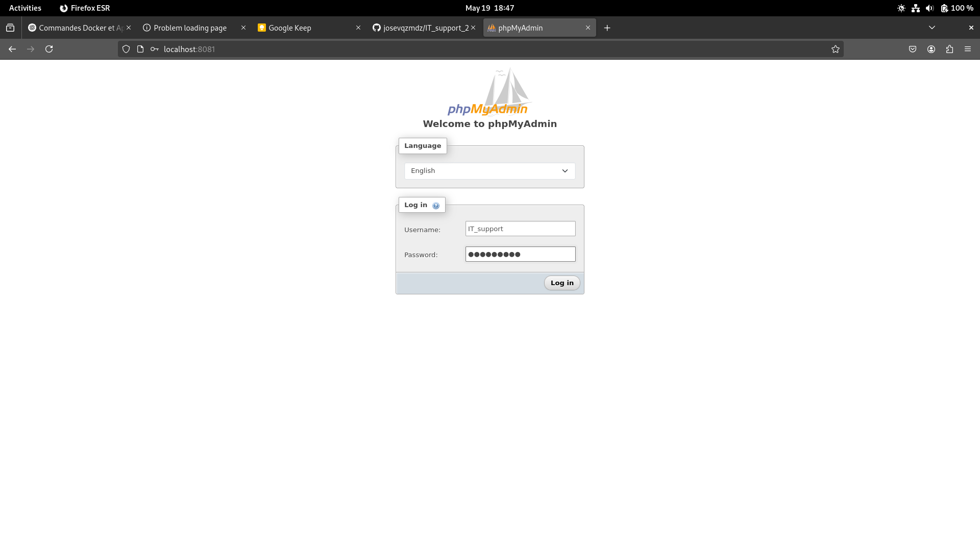

➔ Create a Fake Vulnerability
◆ Simulate a misconfiguration that could be exploited (e.g., an exposed
admin panel, or a world-writable file).
◆ Document this “trap” clearly.

➔ Documentation
◆ Write a short README.md explaining:
● What you did.
● How to run the service.
● What security controls you implemented.
● What the “vulnerability” is and how to fix it.
Deliver as a Git repo or a compressed folder.

Sources:
[1]

[2] nginx docker image: https://hub.docker.com/_/nginx?_gl=1*q44slk*_gcl_au*OTM5OTk5Mzg4LjE3NDcyNzU1MDk.*_ga*MjAxMTY3MTQxMy4xNzQ3Mjc1NTA5*_ga_XJWPQMJYHQ*czE3NDc0Mzk5NTgkbzIkZzEkdDE3NDc0NDQ5NDMkajU5JGwwJGgwJGQ0VnFpQnlJUGdkZDJJUlprbWFnbkhNT2U5dWNkcFgzWVdR

[3] windows path for docker volumes https://forums.docker.com/t/how-can-i-find-my-volumes-in-windows-11/136934/2

[4] configure nginx reverse proxy within a docker container: https://www.youtube.com/watch?v=ZmH1L1QeNHk

[5] Set up docker host hardening to improve container security: https://www.youtube.com/watch?v=RmNqtD9zop4

[6] docker container security cheat sheet:
https://cheatsheetseries.owasp.org/cheatsheets/Docker_Security_Cheat_Sheet.html

[7] WSL2 port forwarding script to linux: https://gist.github.com/xmeng1/aae4b223e9ccc089911ee764928f5486

[8] “creating” a user in docker: https://stackoverflow.com/questions/62988075/what-is-a-clean-way-to-add-a-user-in-docker-with-sudo-priviledges

[9] non root unprivileged users in nginx:
https://hub.docker.com/r/nginxinc/nginx-unprivileged

[10] best security practices in docker:
https://sysdig.com/learn-cloud-native/dockerfile-best-practices/

[11] resources for the development of applications: https://cloud.google.com/solutions/best-practices-for-operating-containers#immutability
(french) https://cloud.google.com/architecture/application-development?hl=fr#immutability

[12] McKendrick, R., & Gallagher, S. (2018). Mastering Docker: Unlock new opportunities using Docker’s most advanced features, 3rd Edition. Packt Publishing Ltd - Introducing dockerfiles, page 32

[13] Build an NGINX server with docker:
https://medium.com/@mrdevsecops/dockerfile-nginx-842ba0a55b82

[14] monter un reverse proxy avec NGINX et docker:
https://youtu.be/786dRn1Ioug?si=NAn91-TjSw1ul1oy

[15] Docker volumes:
https://docs.docker.com/engine/storage/volumes/

[16] Wordpress docker image:
https://hub.docker.com/_/wordpress

[17] Wordpress FPM nginx config file:
https://gist.github.com/md5/d9206eacb5a0ff5d6be0

[18] How to set up PHP, FPM and NGINX in a docker container:
https://www.pascallandau.com/blog/php-php-fpm-and-nginx-on-docker-in-windows-10/

[19] How to setup iptables for docker:
https://stackoverflow.com/questions/30847064/docker-set-iptables-options-in-docker-compose-yml

[20] firewalld and docker:
https://dev.to/soerenmetje/how-to-secure-a-docker-host-using-firewalld-2joo

[21] why firewalls and docker dont get along:
https://erfansahaf.medium.com/why-docker-and-firewall-dont-get-along-with-each-other-ddca7a002e10

[22] Docker security best practices:
https://docs.docker.com/engine/security/

[23] firewalld config:
https://docs.rockylinux.org/guides/security/firewalld-beginners/

[24] docker networking is crazy:
https://www.youtube.com/watch?v=bKFMS5C4CG0

[25] firewalld not allowing docker to start:
https://stackoverflow.com/questions/65213831/failed-to-start-daemon-error-initializing-network-controller-error-creating-de

[26] how to restrict outbound traffic on docker:
https://fruty.medium.com/how-to-restrict-outbound-traffic-on-a-docker-infrastructure-7effc45e313d

[27] block all outbound traffic except to the DNS:
https://stackoverflow.com/questions/71157140/nginx-how-to-restrict-outbound-traffic

[28] configure NGINX as a reverse proxy:
https://docs.nginx.com/nginx/admin-guide/web-server/reverse-proxy/

[29] defaults in firewalld
https://askubuntu.com/questions/1463093/what-is-target-default-of-a-zones-configuration-in-firewalld

[30] how to make persistent logs in docker volumes:
https://stackoverflow.com/questions/54374724/docker-container-save-logs-on-the-host-directory

[31] consistent nginx logs in a docker’s volume:
https://stackoverflow.com/questions/54912615/storing-docker-nginx-access-logs-inside-a-docker-volume

[32] creating the daemon.json for a consistent docker logs:
https://betterstack.com/community/guides/logging/how-to-start-logging-with-docker/
https://www.youtube.com/watch?v=Zlj39xXPu2k

[33] nginx logging docs:
https://docs.nginx.com/nginx/admin-guide/monitoring/logging/

[34] json-file docs:
https://docs.docker.com/engine/logging/drivers/json-file/

[35] compose yaml cheat sheet:
https://devhints.io/docker-compose

[36] bash script to check memory usage:
https://unix.stackexchange.com/questions/91789/script-to-test-for-memory-usage

[37] python and cron scripts to write memory usage:
https://dev.to/vachhanirishi/automating-cpu-and-memory-utilization-logging-with-cron-jobs-on-windows-and-linux-2phl

[38] explaining psutil.cpu_percent
https://stackoverflow.com/questions/49514617/how-psutil-cpu-percent-function-works

[39] crontab actual directory and docs:
https://docs.oracle.com/cd/E19455-01/805-7229/sysrescron-2/index.html

[40] show all config from firewalld:
https://serverfault.com/questions/1094354/how-do-i-display-the-entire-firewalld-state
[41] how to name dockerfiles:
https://stackoverflow.com/questions/26077543/how-to-name-dockerfiles

[42] how to add files with a rootless config:
https://serverfault.com/questions/641264/how-to-add-a-file-to-a-docker-container-which-has-no-root-permissions

[43] php-fpm not found:
https://forums.docker.com/t/docker-nginx-and-php-fpm-file-not-found/136493

[44] nginx healthcheck:

https://forums.docker.com/t/a-simple-http-healthcheck-is-not-working/124171

[45] healthcheck of nginx with correct ports:
https://forums.docker.com/t/docker-container-is-always-unhealthy/141546/3

[46] restart on failure

https://docs.docker.com/reference/compose-file/services/#restart

[47]
https://serverfault.com/questions/1031674/nginx-wont-load-site-on-local-machine

[48] common errors in nginx:
https://www.f5.com/company/blog/nginx/avoiding-top-10-nginx-configuration-mistakes#health-checks

[49] nginx health_checks:
https://docs.nginx.com/nginx/admin-guide/load-balancer/http-health-check/

[50] chmod permits:
https://www.ibm.com/docs/no/aix/7.1.0?topic=c-chmod-command
https://stackoverflow.com/questions/56045077/dockerfile-run-chmod-not-taking-effect

[51] nginx.pid permission denied:
https://stackoverflow.com/questions/63266499/docker-build-fails-with-permission-denied-on-nginx-t

[52]
https://stackoverflow.com/questions/69867171/dockerfile-mkdir-permission-denied

[53] access_log not allowed here:
https://stackoverflow.com/questions/75658528/nginx-log-format-directive-is-not-allowed-here#comment133480195_75658528

http://nginx.org/en/docs/http/ngx_http_log_module.html#log_format

[54] wordpress fpm docs:
https://github.com/mjstealey/wordpress-nginx-docker

[55] phpmyadmin docs
https://hub.docker.com/_/phpmyadmin

[56] bitnami rootless nginx image:
https://hub.docker.com/r/bitnami/nginx

[57] wordpress docker image docs:
https://hub.docker.com/_/wordpress

[58] quick setup of wordpress fpm:
https://gist.github.com/md5/d9206eacb5a0ff5d6be0

[59]
https://github.com/bitnami/vms/issues/894

[60]
https://stackoverflow.com/questions/41766195/nginx-emerg-server-directive-is-not-allowed-here

[61]
https://forums.docker.com/t/mount-container-volume-root-folder/38265/2

[62] avoid access to stack overflow:
https://stackoverflow.com/questions/43019218/how-to-avoid-hosts-to-acess-my-phpmyadmin

[63] password protect phpmyadmin:
https://www.elated.com/password-protecting-your-pages-with-htaccess/

[64] phpmyadmin common types of attacks
https://docs.phpmyadmin.net/en/latest/security.html

[65]
https://github.com/bitnami/charts/issues/18892

[66]
https://stackoverflow.com/questions/40029510/no-write-access-on-wordpress-folder-permissions-for-bitnami-running-on-aws

[67] bitnami docs
https://docs.bitnami.com/general/apps/wordpress/

[68] non root containers
https://docs.bitnami.com/kubernetes/faq/configuration/use-non-root/

[69]
https://stackoverflow.com/questions/42329261/running-nginx-as-non-root-user

[70]
https://docs.bitnami.com/general/how-to/install-wordpress-nginx/

[71] use fail2ban to block excessive logins:
https://serverfault.com/questions/435016/custom-fail2ban-filter-for-phpmyadmin-bruteforce-attempts
https://serverfault.com/questions/434651/setting-up-fail2ban-to-ban-failed-phpmyadmin-login-attempts

[72] config fail2ban in nginx through docker
https://seifer.guru/2021/01/2021-01-fail2ban-with-nginx-in-container/

[73]
https://stackoverflow.com/questions/57855922/permission-denied-for-cp-command-on-bitnami-nginx-docker-image

[74]
https://docs.bitnami.com/google/apps/wordpress-pro/administration/understand-file-permissions/
Unrelated sources:
https://forums.raspberrypi.com/viewtopic.php?t=371884

https://github.com/nginx/docker-nginx/blob/master/stable/debian/Dockerfile

https://stackoverflow.com/questions/77980040/modify-nginx-base-image-with-a-dockerfile

https://www.digitalocean.com/community/tutorials/how-to-run-nginx-in-a-docker-container-on-ubuntu-22-04

https://www.docker.com/blog/how-to-use-the-official-nginx-docker-image/

https://stackoverflow.com/questions/77980040/modify-nginx-base-image-with-a-dockerfile

cheat sheet:
https://kapeli.com/cheat_sheets/Dockerfile.docset/Contents/Resources/Documents/index

official docs
https://docs.docker.com/reference/dockerfile/

https://docs.docker.com/build/building/best-practices/

https://docs.docker.com/build/concepts/dockerfile/

https://stackoverflow.com/questions/69493762/visual-studio-code-showing-error-property-stages-is-not-allowed-property-param

How to enter docker bash
https://stackoverflow.com/questions/30853247/how-do-i-edit-a-file-after-i-shell-to-a-docker-container

How to delete everything – images, volumes, etc
https://stackoverflow.com/questions/44785585/how-can-i-delete-all-local-docker-images
docker system prune -a --volumes

https://hub.docker.com/_/wordpress

https://askubuntu.com/questions/996718/ubuntu-repository-does-not-have-a-release-file

How to see latest logs in composer:

sudo journalctl -u docker.service --no-pager | tail -n 100

https://stackoverflow.com/questions/30847064/docker-set-iptables-options-in-docker-compose-yml

https://nginx-extras.getpagespeed.com/modules/traffic-accounting/

chemiloco@chemiloco:~/Documents/IT_support_test_french$ sudo docker compose up
[+] Running 1/1
✘ Network it_support_test_french_default Error 0.0s
failed to create network it_support_test_french_default: Error response from daemon: Failed to Setup IP tables: Unable to enable SKIP DNAT rule: (iptables failed: iptables --wait -t nat -I DOCKER -i br-26ae5ba3cfa9 -j RETURN: iptables: No chain/target/match by that name.
(exit status 1))

Seems this is a common issue with docker. Restarting it helped.
https://github.com/bigbluebutton/docker/issues/188

random commands:
chmod +x set-cron-permission.sh
sudo chown -R username:groupname /path/to/directory

docker inspect ITSupport-nginx

sudo firewall-cmd --permanent --new-zone=docker_zone
sudo firewall-cmd --permanent --zone=docker_zone --add-source=172.18.0.0/24
sudo firewall-cmd --permanent --zone=docker_zone --add-port=8080-8081/tcp
sudo firewall-cmd --permanent --zone=docker_zone --add-port=3306/tcp

sudo firewall-cmd --permanent --add-port=8080/tcp
sudo firewall-cmd --permanent --add-port=8081/tcp
sudo firewall-cmd --permanent --add-port=3306/tcp

# Autorisez le trafic du réseau Docker
sudo firewall-cmd --permanent --zone=public --add-rich-rule='rule family="ipv4" source address="172.18.0.0/24" accept'
sudo firewall-cmd --permanent --new-zone=docker
sudo firewall-cmd --permanent --zone=docker --add-source=172.18.0.0/16
sudo firewall-cmd --permanent --zone=docker --add-port=8080/tcp
sudo firewall-cmd --reload

docker exec ITSupport-nginx netstat -tulnp | grep 80

docker logs ITSupport-nginx
docker exec -it ITSupport-nginx /bin/sh
nginx -t
nginx -g 'daemon off;'

# Régénérer un certificat valide pour localhost
openssl req -x509 -nodes -days 365 -newkey rsa:2048 \
-keyout ./certs/server.key -out ./certs/server.crt \
-subj "/CN=localhost" -addext "subjectAltName=DNS:localhost"

docker exec -it wordpress bash
ls -la /var/www/html/wp-content
docker exec -it nginx bash
ls -la /var/www/html/wp-content

